**Event Management System**

This project is of an Event Management System of a college fest. This system will be able to keep track of all the events organized in the fest for students participating in the events via online mode. The information about all events such as their ID’s, events names, expected dates, registration fees etc. can be stored in the database. A set of users and their information is present – these users are all associated via their user ID’s, names and registration details. There is an Admin panel giving all the facilities to the super-user Admin like able to manage the events, add new events, see the registered users for particular event, delete an event. A separate panel is given for users and the admin. The basic objective of the project is to provide an ideal software solution for event management, to protect user data and to simplify user experience to for event booking.

Any customer can register with his details such as login credentials if he wants to participate in college event.ID, name of event and fees paid is stored within user database. The customer can issue and cancel events at any time before the date of event. Every issue transaction has an associated transaction ID, the ID of the user and event registered and an issue date.

**Entities and Attributes**

**Event**

1. Event ID (primary key, distinct, NOT null)
2. Name
3. Start date
4. End Date
5. Registration fee

**User**

1. User ID (primary key)
2. Name
3. username
4. password
5. Contact No.

**Transaction**

1. Transaction ID (primary key)
2. Amount
3. Event ID (foreign key from Event)
4. Event Name (foreign key from Event)
5. User ID (foreign key from User)
6. User name (foreign key from User)

**Payment**

1. Payment ID (primary key)
2. Amount Paid
3. Date
4. Name (foreign key from User)
5. username (foreign key from User)
6. Event ID (foreign key form Event)

**Relations**

* CUSTOMER registers for Event (N-1)
* CUSTOMER cancels the registration (1-N)
* EVENT confirms the transaction (1-1)
* Transaction makes payment (N-1)

**ER – Diagram**

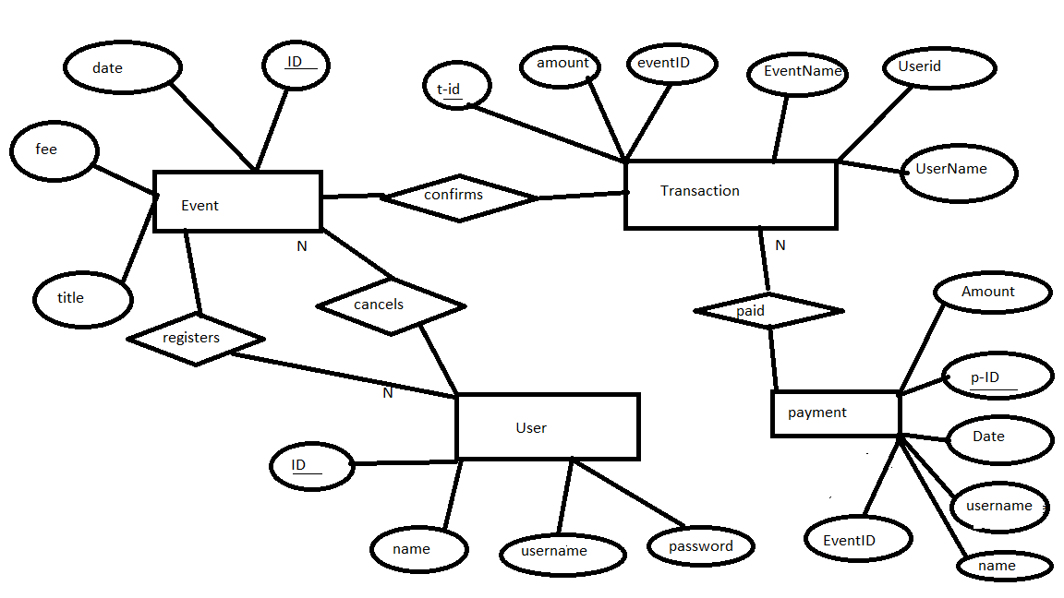

**Schema**

event (title, ID, date,fee)

user (ID, name, username, password)

transaction (amount, t-ID, eventID, eventName, Userid, UserName)

payment(Amount, p-ID, Date,UserName, Username, EventID)

**Functional Requirements**

Technology –

Frontend – HTML, CSS, Bootstrap, PHP

Backend – mysql server, PHP